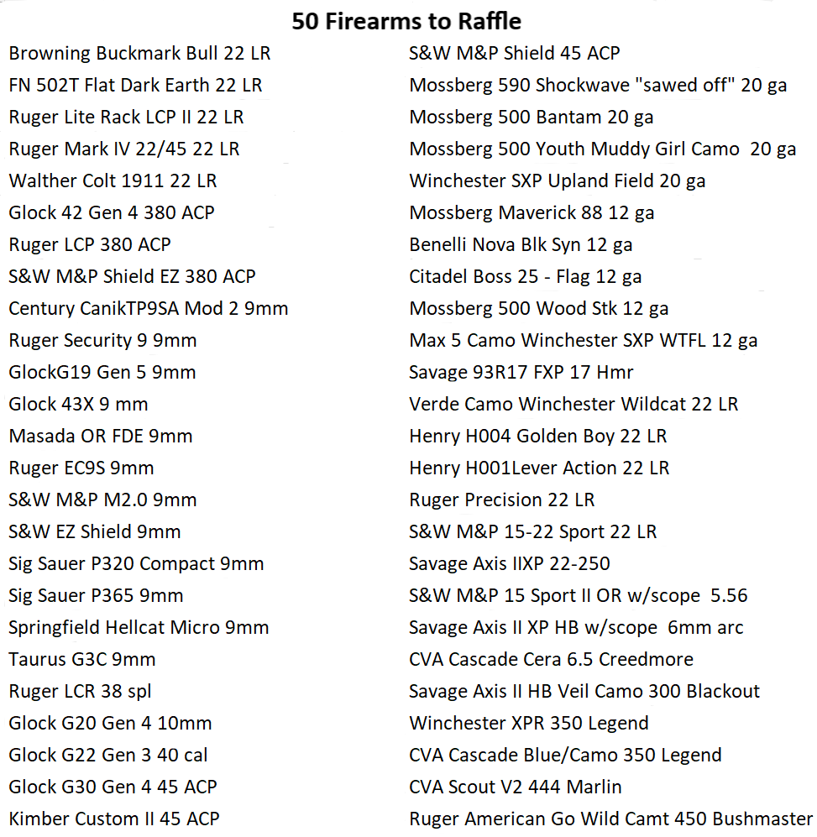

Tickets may be purchased online at www.alkoransportsmansraffle.com or from an Al Koran Shriner.

Must be 18 years of age to enter and 21 to receive a handgun. If a winner is ineligible to receive a prize under relevant federal and state laws or local laws, they must take the optional gift card. If winner is unable to pick up firearm in person, it may be shipped to nearest FFL Dealer at winner’s expense. Fin-Feather and Fur Outfitters will handle all transactions of prizes awarded.

