UNITS

KRAZY KOPS
Meetings: 4th Monday – DINNER 6:00 PM – Teamz Restaurant, 6611 Eastland Rd., Middleburg Heights, OH

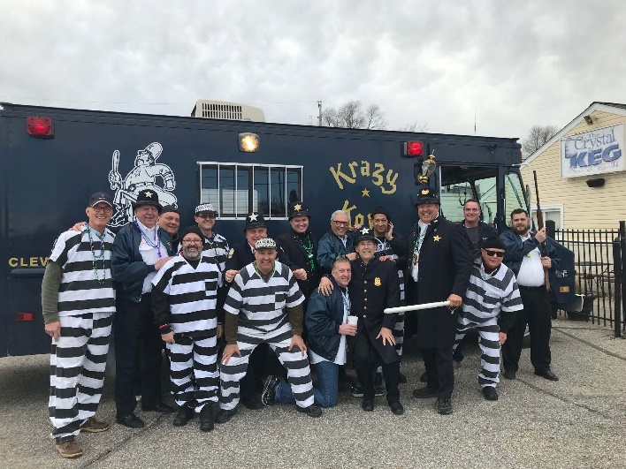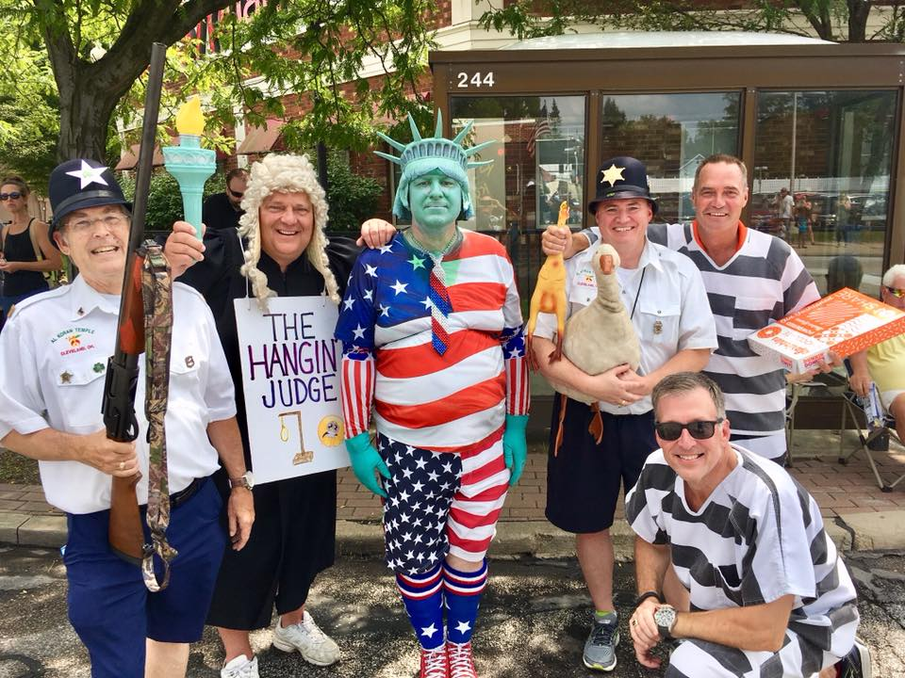

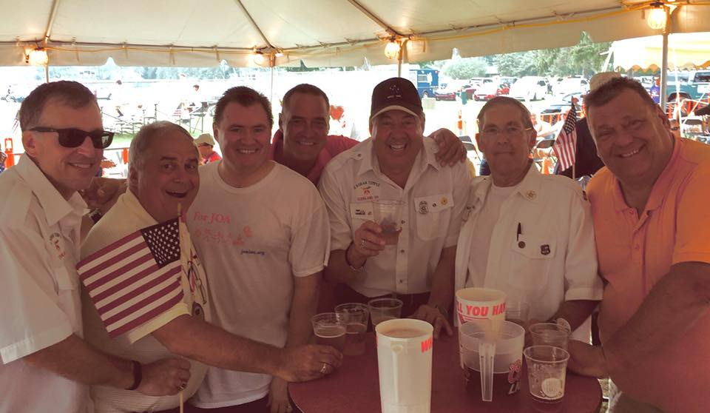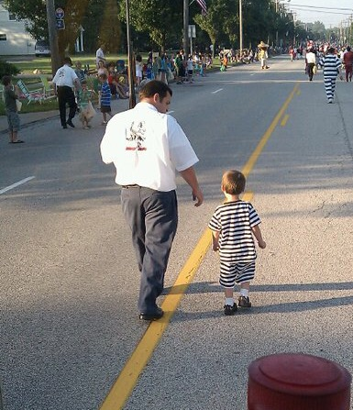
TOM KLECAN - DIRECTOR MIKE SPISAK – SECRETARY/TREASURER
C: (440) 827-6174 C: (216) 225-0703
E: klecantom@hotmail.com E: mjspisak@gmail.com
https://www.facebook.com/groups/134669776555354

KORVETTES
Meetings: 2nd Thursday – Cleveland East Side suburbs various locations

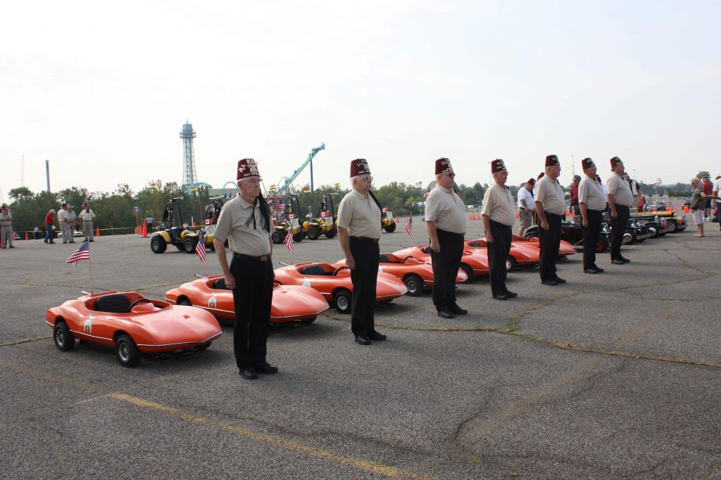
DON DAVIS - DIRECTOR MIKE DAVISON - SECRETARY
R: (440) 942-1721 C: (330) 608-2414
C: (440) 336-3540 E: mikedavison123@aol.com
E: sskdss@sbcglobal.net
HUNTERS
Meetings: 2nd Monday – 7:00 PM – Al Koran Office, 6801 Engle Rd., Suite B, Middleburg Hts. Ohio
AL PAYNTER - CHIEF BRANDON GOULD - SECRETARY
C: (216) 346-3162 C: (440) 225-8205
E: mrclean274@aol.com E: bmgould@live.com

LORAIN COUNTY FIRE BRIGADE
Meetings: 3rd Friday – 11:00 AM – LUNCH WITH SPOUSES - Sugar Creek Restaurant
5196 Detroit Rd., Sheffield, OH
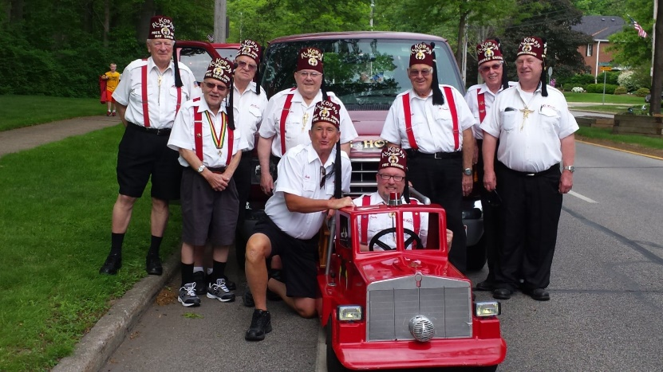
SCOTT CROXFORD – DIRECTOR MIKE MOORMAN - SECRETARY
C: (440) 822-4107 C: (216) 224-2836
E: scott_croxford@hotmail.com E: rolypolyfarm@yahoo.com

LEGION OF HONOR
Meetings: 4TH Monday – 6:30 PM - St. Matthews Church, 9549 Highland Dr., Brecksville, OH
AL KORAN MILITARY VETERANS WELCOME
AL PAYNTER - COMMANDER JACK CONNER - ADJUTANT
C: (216) 346-3162 C: (440) 590-5260
E: mrclean274@aol.com E: jacmar@jeconner.com

BS (BOURBON-STOGIES)
Meetings: Various times and locations in Northeast Ohio listed on Al Koran website and newsletter
BRANDON GOULD - DIRECTOR MIKE SPISAK – SECRETARY/TREASURER
C: (440) 225-8205 C: (216) 225-0703
E: bmgould@live.com E: mjspisak@gmail.com
https://www.facebook.com/groups/332428982188857

MID-OHIO
Meetings: 1st Monday – Dan Lew’s Exchange (DLX) 28 N. Main St., Mansfield, OH
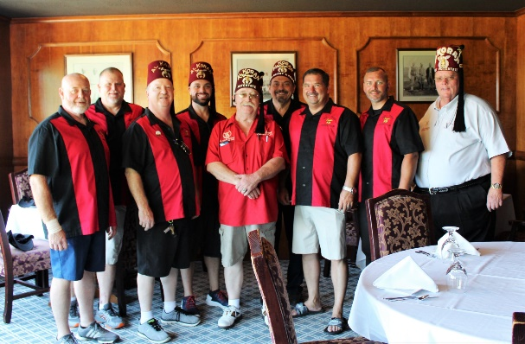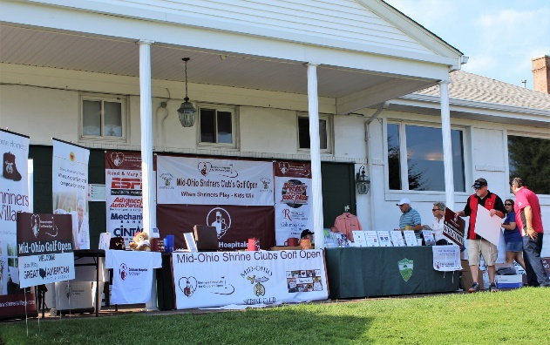
MIKE MIRANDA – PRESIDENT BILLY BRAGG-SECRETARY/TREASURER
C: (419) 295-2586 C:
E: mikejmiranda@hotmail.com E: billbragg@zoominternet.net
https://www.facebook.com/MidOhioshriners

CLUBS

MARINERS
Meetings: 3rd Tuesday – CHOW & GROG WITH SPOUSES AT 1800 HOURS - EDGEWATER YACHT CLUB
6700 Memorial Shoreway NW, Cleveland, OH

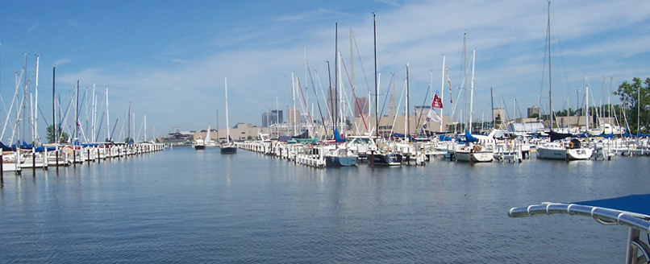
RONN MURPHY– COMMODORE JIM DETTMER - SECRETARY/TREASURER
C: (216) 702-6785 R: (440) 570-6146
E: murphyrm2361@gmail.com E: jdettmer13@gmail.com
HILLBILLY CROOKED RIVER CLAN #16
Meetings: 4TH Wednesday – 5:30 PM SOCIAL HOUR WITH SPOUSES – 6:00 PM POTLUCK SUPPER
St. Matthews Church - 9549 Highland Dr., Brecksville, OH
RONN MURPHY – RABAN OF THE CLAN MARK BOLLINGER-KEEPER OF THE QUILL
C: (216) 702-6785 C: (440) 429-7094
E: murphyrm2361@gmail.com E: mjbollinger62@gmail.com

EAGLE SHRINE CLUB
Meetings: 2nd TUESDAY – SOCIAL HOUR 5:30 PM WITH SPOUSES – DINNER 6:00 PM
PAINESVILLE MASONIC TEMPLE, 88 N ST CLAIR ST, PAINESVILLE, OH

KEN WEIDIG – PRESIDENT FRANK MASTERSON-SECRETARY
C: (440) 749-9202 C: (440) 840-4678
E: kaydig@sbcglobal.net E: battman1956@sbcglobal.net

LAKEWOOD SHRINE CLUB
Meetings: 1ST WEDNESDAY – SOCIAL HOUR 5:00 PM WITH SPOUSES – DINNER 6:00 PM
CLEVELAND YACHTING CLUB - 200 Yacht Club Dr, Rocky River, OH
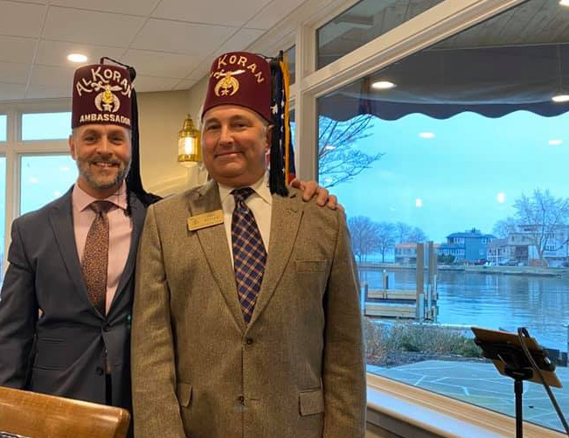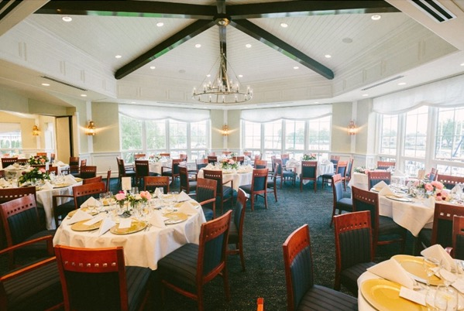
MARK BOLLINGER – PRESIDENT BOB BERTEAU -SECRETARY
C: (440) 429-7094 C: (216) 337-9849
E: mjbollinger62@gmail.com E: rdb379@sbcglobal.com
https://www.facebook.com/groups/1710652915856760

YOUNGSTOWN SHRINE CLUB
Meetings: 3RD THURSDAY - SOCIAL HOUR 5:30 PM - DINNER 6:30 PM - MEETING 7:00 PM
YOUNGSTOWN SHRINE CLUB, 1735 W. SOUTH RANGE ROAD NORTH LIMA, OH
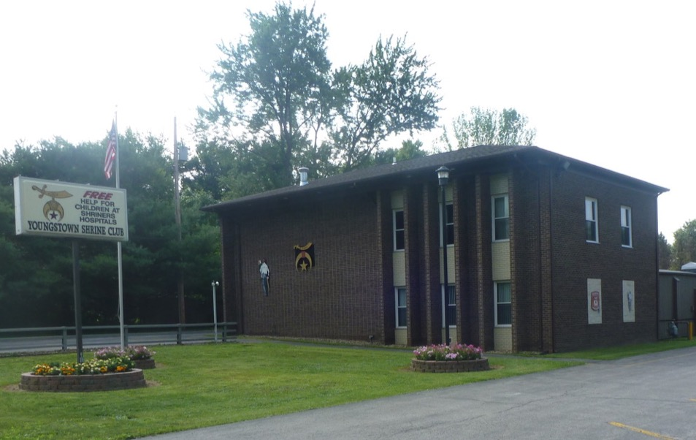
ZEL BUSH – PRESIDENT JIM HAZLETT - SECRETARY
C: (330) 503-5992 C: 330-651-7185
E: zbush@aol.com E: jimzee68@yahoo.com
http://youngstownshrineclubhallandpavilion.org/
https://www.facebook.com/YtownShrineClub/

MANSFIELD SHRINE CLUB
Meetings: 1ST THURSDAY, 6:00 PM DINNER WITH SPOUSES AT VARIOUS MANSFIELD RESTAURANTS
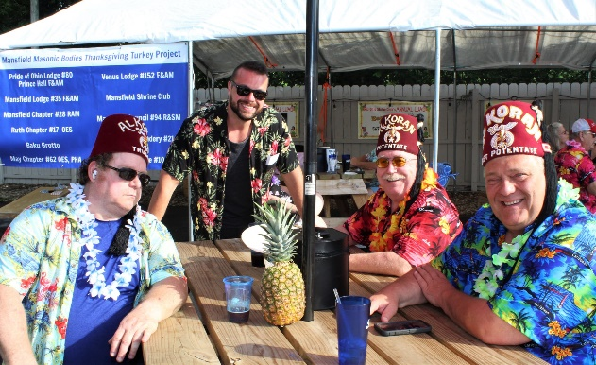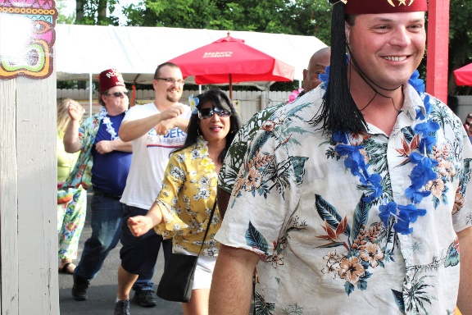
BRUCE JOSPEH – PRESIDENT JERRY GUNDRUM-SECRETARY
C: (419) 571-1712 C: (419) 884-1295
E: jofotohio@aol.com E: jfg1322@aol.com
https://www.facebook.com/mansfieldshriners/

MASSILLON SHRINE CLUB
Meetings: 3RD WEDNESDAY -5:30 PM SOCIAL HOUR WITH SPOUSES – 6:30 PM DINNER
MASSILLON MASONIC TEMPLE - 333 SECOND ST. SW, MASSILLON, OH
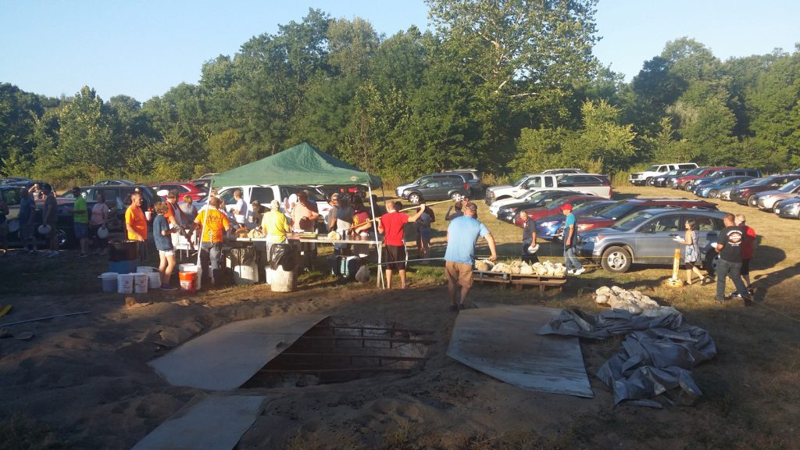
PAUL WESTLAND – PRESIDENT BILL KEMP-SECRETARY
C: (330) 806-7088 C: (330) 806-9613
E: Prez@Massillon.org E: silk1951@gmail.com
http://massillonshriners.org/

